**ISDS 552**

**Project on**

**Car Dealership (Sales)**



**By**

**Team- S3**

**Deepam Khirwar**

**Harshita Didwania**

**Kavindu Walimunige**

**Sanchit Singh**

**Sathiya Priya Jeevanandan**



**System Request – Car Dealership Project**

**Use Case Diagram for Car Dealership System**

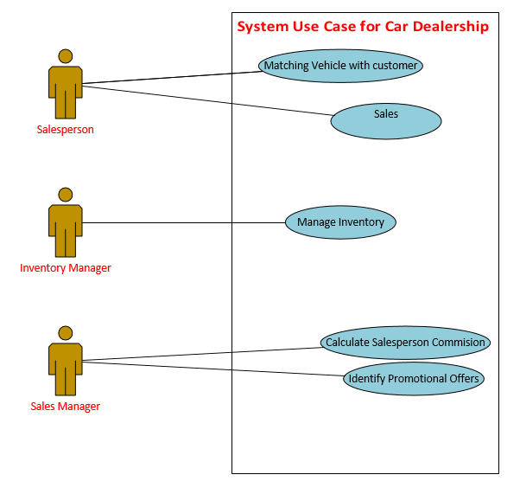

**Use case 1: Match Vehicle with Customer**

|  |  |  |  |
| --- | --- | --- | --- |
| **Use Case Name**: Match Vehicle with Customer (on-site) | | **ID**: 01 | **Importance Level**: High |
| **Primary Actor**: Salesperson | **Use Case Type**: Brief, Essential | | |
| **Stakeholders and Interests:**   * The Salesperson helps the customer to choose from an internal or external inventory of cars when he visits the showroom. * The essential data collected from the customers and stored in the system. | | | |
| **Brief Description:** This use case describes how a customer can be matched with his/her vehicle on-site and the customer preferences are saved in the system. | | | |
| **Trigger:** The customer providing salesperson preferences.  **Type:** External | | | |
| **Relationships:**  **Association:** Customer  **Include:**  **Exclude:**  **Generalization:** | | | |
| **Basic Flow of Events:**   1. Customer visits on-site showroom. 2. Salesperson records the preferences of the customer and stored in the database. 3. The vehicles are provided to the customer based on their choices from the internal inventory, otherwise from the external inventory. 4. The test drive is also provided and the data including preferences in extra accessories is recorded. | | | |
| **Sub Flows:**  **S-1:** Vehicle is not available in internal inventory but present in external inventory.   * Dealers are alerted.   **S-2:** Vehicle is not present in internal as well as external inventory.   * Customer is informed as soon as vehicle comes in the inventory. | | | |
| **Alternative/Exceptional Flow:** Customer chooses car through websites. Steps 4 and 5 are iterated. | | | |

|  |  |  |  |
| --- | --- | --- | --- |
| **Use Case Name**: Match Vehicle with Customer (online) | | **ID**: 01 | **Importance Level**: High |
| **Primary Actor**: Customer | **Use Case Type**: Brief, Essential | | |
| **Stakeholders and Interests:**   * Customers can search all the available cars from the dealer’s website. * The Salesperson helps the customer to choose from an internal inventory of cars when he logs in to the website. * No data is stored. | | | |
| **Brief Description:** This use case describes how a customer can be matched with his/her vehicle present in the internal inventory through the website’s search tab. | | | |
| **Trigger:** The customer providing the details of the vehicle he/she wants.  **Type:** External | | | |
| **Relationships:**  **Association:**  **Include:**  **Exclude:**  **Generalization:** | | | |
| **Basic Flow of Events:**   1. Customer makes an account and logs in. 2. Customer gives the vehicle type he/she wants. 3. Vehicles present in the internal inventory is matched with the customer’s search criteria. 4. Customers book appointment with the dealership if the car is present. | | | |
| **Sub Flows:**  **S-1:** Vehicle is not available in internal inventory.   * Customer can continue searching * Customer can call the dealership and book on-site appointment.   **S-2:** Vehicle is present in the internal inventory.   * Customer books appointment with the car dealership to finalize the car. | | | |
| **Alternative/Exceptional Flow:** | | | |

**Activity Diagram for Match Vehicles with Customer (On-site)**

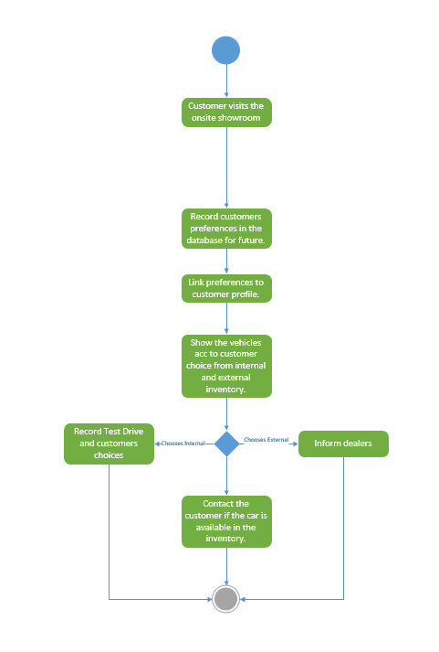

**Activity Diagram for Match Vehicles with Customer (Online)**

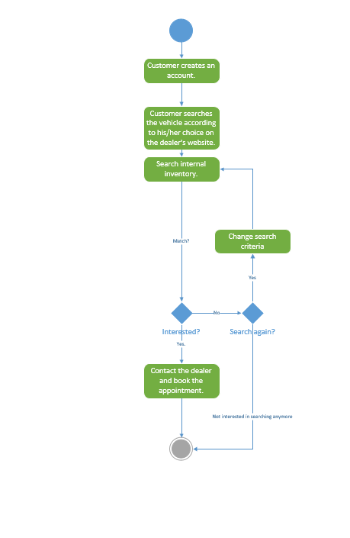

**Use Case 2. Sell Car:**



**Activity Diagram of Use Case 2:**

A screenshot of a social media post

Description generated with very high confidence

**Use Case 3. Inventory Management:**

|  |  |  |
| --- | --- | --- |
| **Use Case Name: Inventory Management** | **ID:** 3 | **Importance level:** High |
| **Primary Actor:** Inventory Manager | **Use Case Type:** Overview, Essential | |
| **Stakeholders and Interests:**  The inventory of the company is managed and controlled by the Inventory manager. The inventory manager reviews the orders from the customers and also updates the order accordingly. And, if required the inventory manager also places new orders to the manufacturers accordingly. | | |
| **Brief Description:**  How the inventory is organized and managed in the company is described in this case. | | |
| **Trigger:** When a sale is initiated by a car dealership or new product is launched and if there is a requirement unavailability.  **Type:** Internal | | |
| **Relationships:**  **Association:** Inventory manager, Product Manufacturer, Sales Manager and Financial Manager.  **Include:** The car requested by the customer which is not available in the stock.  **Extend:**  **Generalization:** | | |
| **Normal Flow of Events:**   1. A sale is initiated by the car dealership, when a customer selects a car. 2. Inventory manager raises a request to update the inventory. 3. The inventory update request is approved by the Financial Manager. 4. A new order is placed to the manufacturers by the Inventory Manager. 5. The inventory stock is updated accordingly by the Inventory Manager. | | |
| **Sub-flows:**  **S1:** If there is an unavailability of a car in the internal stock.  A request is raised for the inventory by the Sales Manager as per the customer requirement. If there is unavailability of the product in the inventory, the Inventory Manager will raise a request for updating the inventory.  **S2:** Customer selects a trade-in option.  Once the trade-in is approved by the Inventory Manager, the vehicle is added to the internal inventory. | | |
| **Alternative/Exceptional Flow:**  The Inventory Manager updates the inventory after the sale of the product. | | |

**Activity Diagram**

Car Selection by Customer

Inventory Update External Inventory

Reserve Vehicle

Request

Internal Inventory

Trade-in

Vehicle addition in internal inventory

No Trade-in

Approved by

Sell Vehicle

inventory manager

Update inventory

Not approved

Alert inventory manager

**Use case 4: Calculate Salesperson commission**

|  |  |  |
| --- | --- | --- |
| **Use Case Name**: Calculate Salesperson commission | **ID**: 04 | **Importance Level**: High |
| **Primary Actor**: Sales Manager, Accountant | **Use Case Type**: Brief, Essential | |
| **Stakeholders and Interests:**   * According to the sales records, the system calculates the weekly commission pay and sends over to the Sales manager for approval. * Sales manager approves individual sales person’s weekly commission. * Commission will be added to the sales person’s final pay check by the accounting department. | | |
| **Brief Description:** This use case explains the process of calculating a sales person’s commission weekly by the system. The commission is calculated by the system as a percentage of total sales done by a sales person for the week. The commission should be approved by the Sales manager. | | |
| **Trigger:** The system extracts data from the sales history and calculates the total sales commission for the week by each sales person.  **Type:** Internal | | |
| **Relationships:**  **Association:** Sales manager and Accountant  **Include:** Sales Department and Finance department  **Exclude:** Unauthorized personnel.  **Generalization:** | | |
| **Basic Flow of Events:**   1. The system records data from weekly sales history for each sales person 2. The system calculates sales person commission based on their sales as a percentage 3. Sales manager inspects the sales commission report and approves it. 4. Approval is received by the accounting department and added to the pay check. | | |
| **Sub Flows:**  **S-1:** The sales person commission strategy and the percentage is determined by the sales manager. Any changes in strategy should be authorized by sales manager. | | |
| **Alternative/Exceptional Flow:**   * If system is down or data is corrupted, the sales person can submit a record of transactions manually and sale manager can add them to the system. | | |

Activity Diagram

Commission strategy set by sales manager

System records the data from sales history

Calculate the sales commission by the system

The commission amount is added to the sales person’s pay check by the accountant department

Denied

Is approved by Sales manager

Sales person re-submit Sales history for approval

**Use Case 5: Promotional Offer**

|  |  |
| --- | --- |
| **Use Case Name**: Promotional Offers | **ID:** 005 Importance Level: High |
| Primary Actor: Sales Manager, Finance Manager | Use case type: Overview, Essential |
| Stakeholders and interests: Customers are offered catchy promotional offers to attract them to buy more products | |
| Brief description:  This use case describes how a particular promotional offer is applied. | |
| Trigger: Sales Manager determines the promotional offer  Type: Internal and External | |
| Relationships  Association: Sales Manager, Financing Manager, Car dealership Sales system  Include: Finance Department | |
| Normal Flow of Events:   1. Sales Manager selects the item, promotional offer, promotional price and period. 2. Sales Manager sends the offer to financing manager for approval. 3. If approved, promotions are applied and is open to the customers. 4. The discounted rates are visible to the customers. 5. If not, then Financing Manager responds to Sales Manager with disapproval. 6. The actual rates are visible to the customer. | |
| Sub Flows: | |
| Alternative Flows: The item is not eligible for promotional offer. | |
| Post Condition: The final price is displayed to the customer with or without discounts | |

Activity Diagram of Use case 5

Promotional offer applied

Yes

No

Approve

Deny

Finance Manager’s decision

Show Original Price

Show Discounted Price

Sales Manager selects items, promo price and promotional time period

Promotional data sent to Financial Manager for approval

Open Promotional offers to staffs and customers